# Exercise 1: Download and preview the Quire project template

1. Download the project template

Steps:

* 1. Go to the DHOxSS Canvas page for our session and download the zip file named ‘quire_template.zip’
  2. Extract the contents of the file wherever you like on your system

1. Preview the project template

Steps:

* 1. Open your console
     + If you are on macOS, this will be the Terminal. If you are on Windows, this will be PowerShell or Command Prompt
  2. Make sure your console is in the same directory as the project template. Do this by using the **‘cd path/to/the/template’** command (change directory). For example, if your project is still in the Downloads folder, run **‘cd Downloads/quire_template’**
  3. In the console, run the command **‘quire preview’**
  4. Copy the URL provided and open it in your web browser

The URL is printed after ‘Server at’ in the console

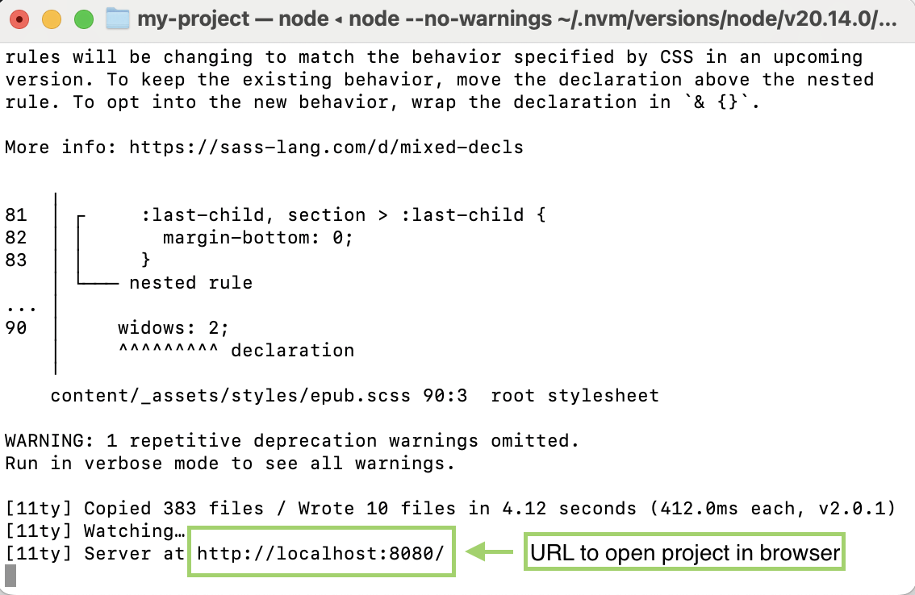

When you follow the URL in your browser, you should see the title page of project template



# Exercise 2: Give your project a title and add your name

* Open publication.yaml in your code or text editor.[1]

Steps:

* 1. Open the ‘data’ folder at the directory ‘quire_template/content/data’. You will find the publication.yaml file there

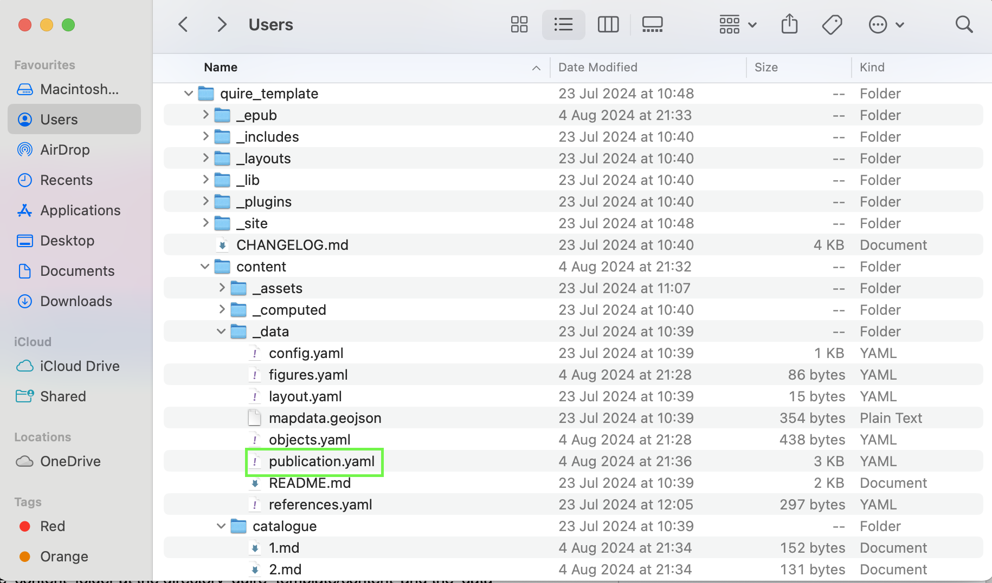

* Enter a title and subtitle in the ‘Title & Description’ section

Steps:

* + Find the ‘Title & Description’ section of the publication.yaml file
  + Give your project a title, and, optionally, a subtitle

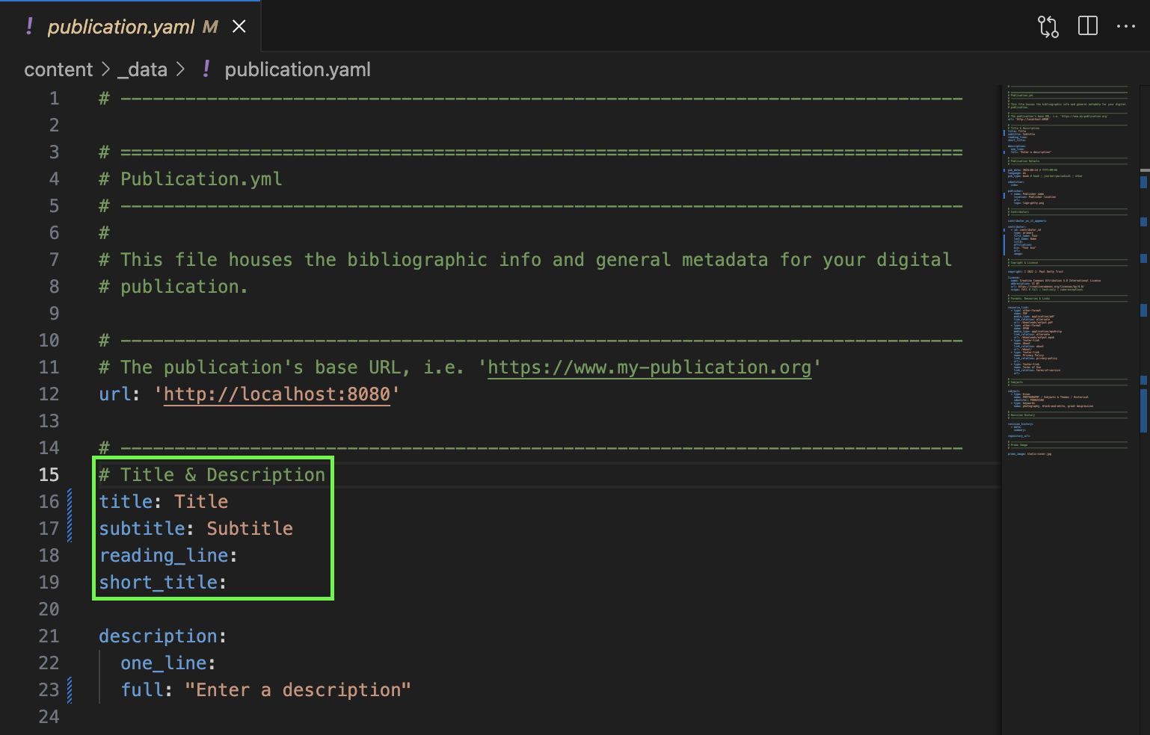

* Enter your name in the ‘Contributors’ section

Steps:

* + Find the ‘Contributors’ section of the publication.yaml file
  + Enter your first and last name

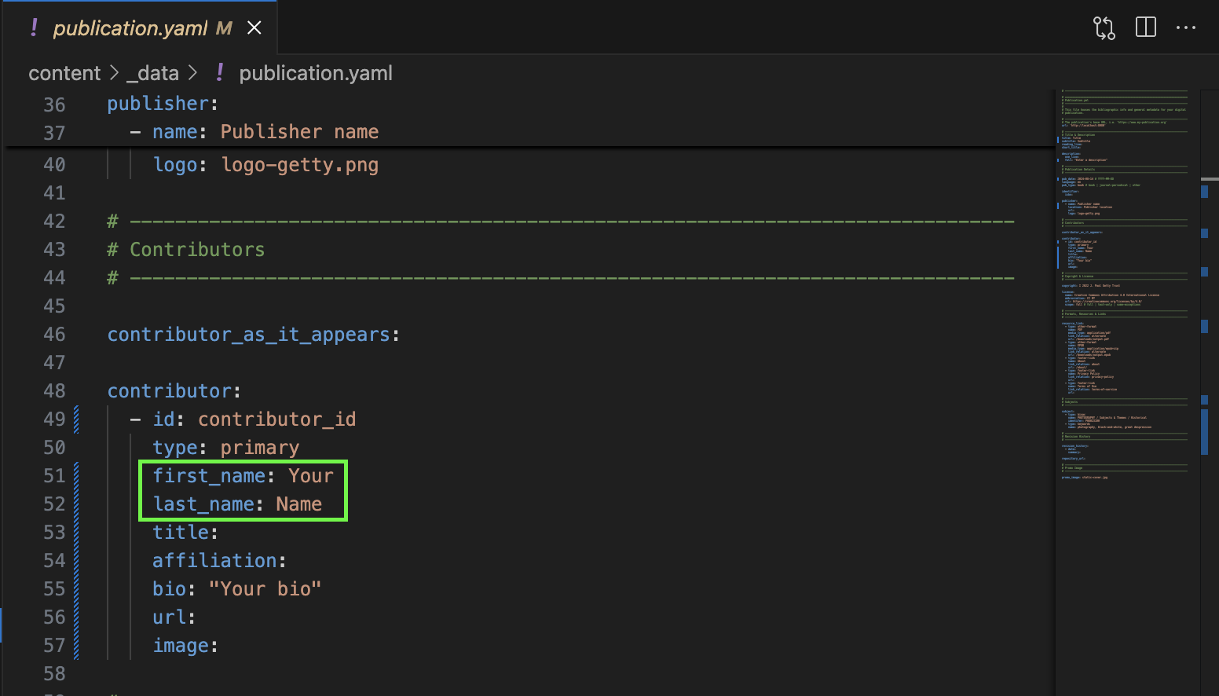

* Save the file and view the changes

Steps:

* + Save the publication.yaml file
  + Stop the current preview by pressing **ctrl + c** in the console
  + Run the command **‘quire preview’**
  + Check the title page and make sure the title and name you entered in publication.yaml appear

Note: It is not always necessary to stop the current preview and rerun the preview command to see changes. This time it is, but for future changes, try simply saving the file and looking for the changes first. They may appear without you having to rerun the preview command



# Exercise 3: Write a brief introduction

1. Open the intro.md file

Steps:

* 1. Open the intro.md file in the ‘quire_template/content/’ folder

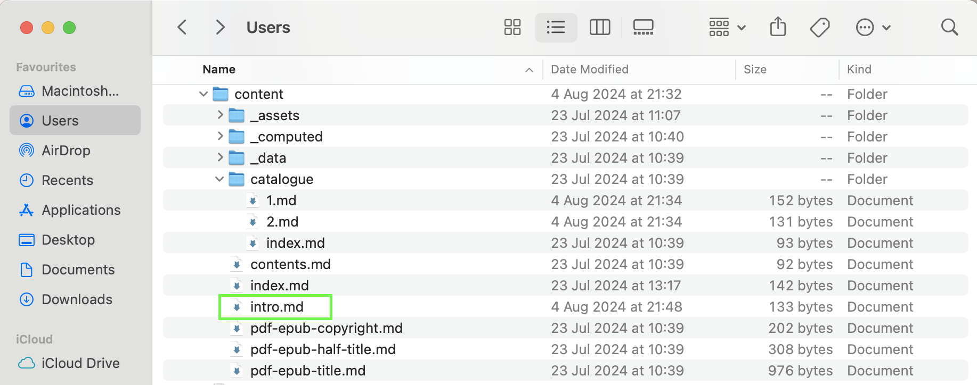

1. Write an introduction for your project where it says ‘Write an introduction of your project here’

Steps:

* 1. Find where it says ‘Write an introduction for your project here’, erase that sentence, and write your own brief introduction (a sentence or two for now, you can always come back and add more)

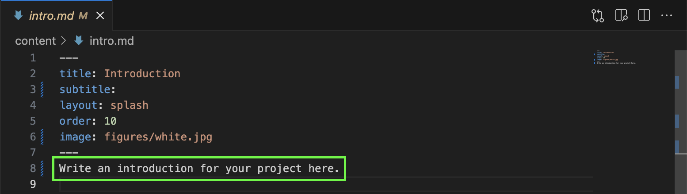

1. Save the file and view the changes

Steps:

* 1. Save the intro.md file
  2. Go to the introduction page of the project in the browser and view the changes. To get there from the title page, use the arrow at the top of the page or the menu in the top right



Note: If you do not see your changes, try restarting the preview by stopping the current preview in the console (ctrl + c) and rerunning the **‘quire preview’** command

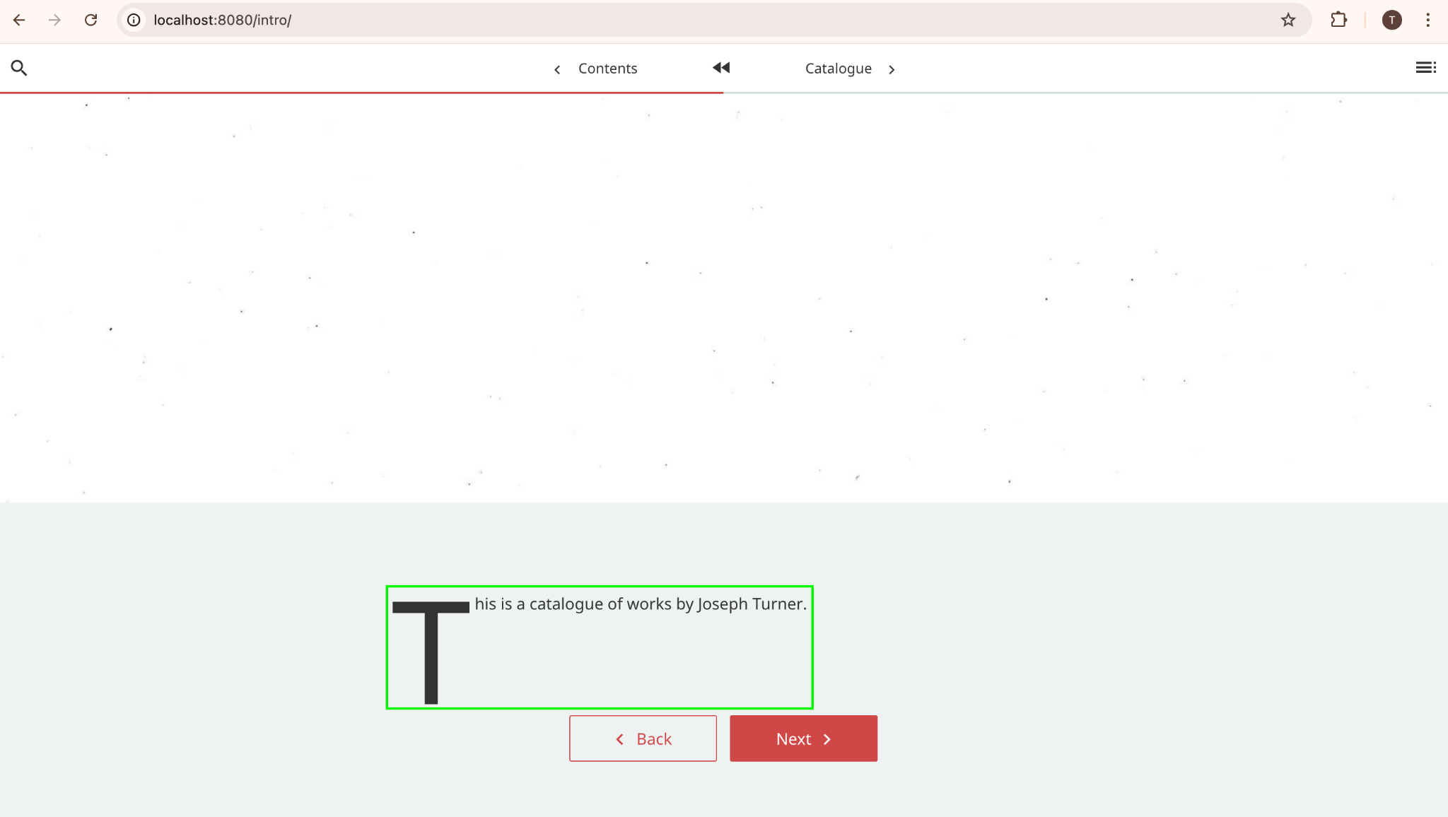

# Exercise 4: Use the Linked Art in Quire extension

1. Add a figure

Steps:

* 1. Go to the Yale LUX page for your first chosen object and locate the link to its Linked Art record (LUX homepage: <https://lux.collections.yale.edu/>)

In this is example, we will add a figure of the painting ‘Andernach’ by Joseph Turner to figures.yaml https://lux.collections.yale.edu/view/object/5caf73a7-52d8-450b-a6fd-5a4ed68b313a

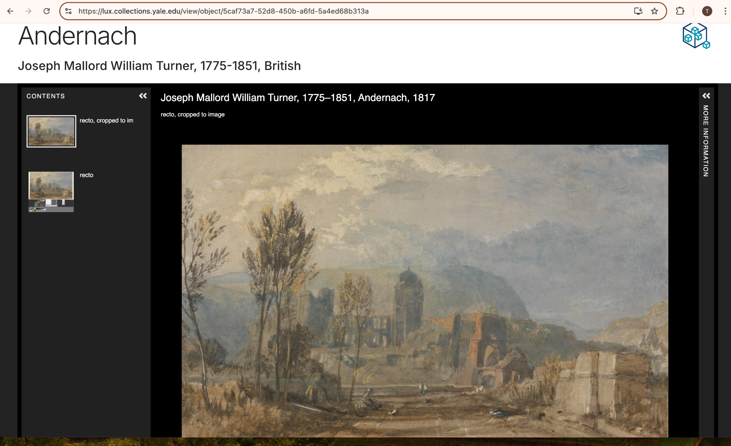

* 1. Scroll down the page. The Linked Art record will be in the ‘Data Sources’ section on the right

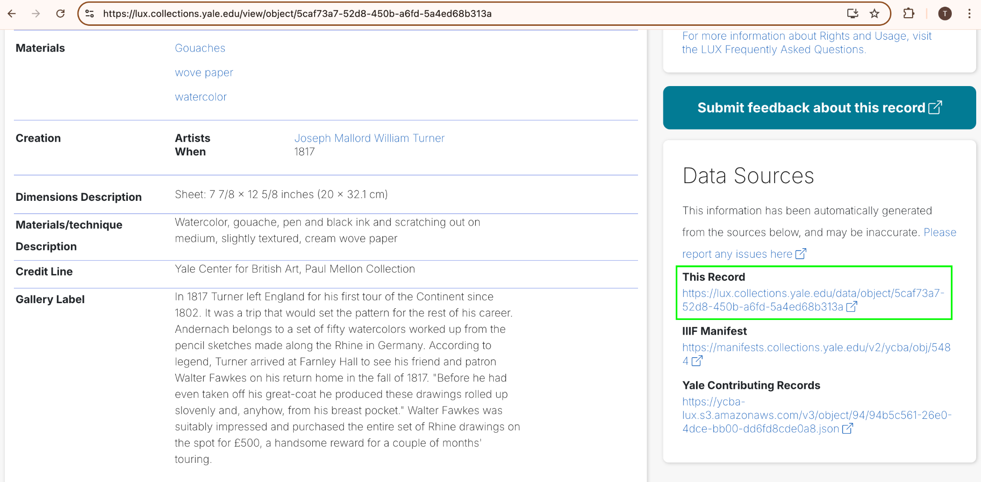

* 1. Copy the URI of the record
  2. Stop the quire preview by pressing ctrl + c in the console
  3. Use the Linked Art record URI to add the painting to your project. Do this by running the command **‘quire add figure <uri>’** in the console

After running the command, the figure has been added to figures.yaml with the ID ‘1’

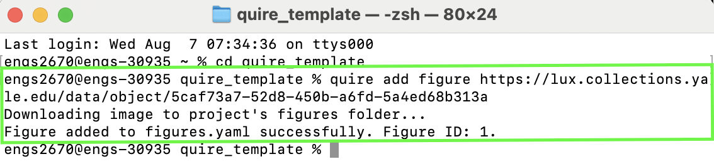

* 1. Open the figures.yaml file in the ‘quire_template/content/_data’ folder

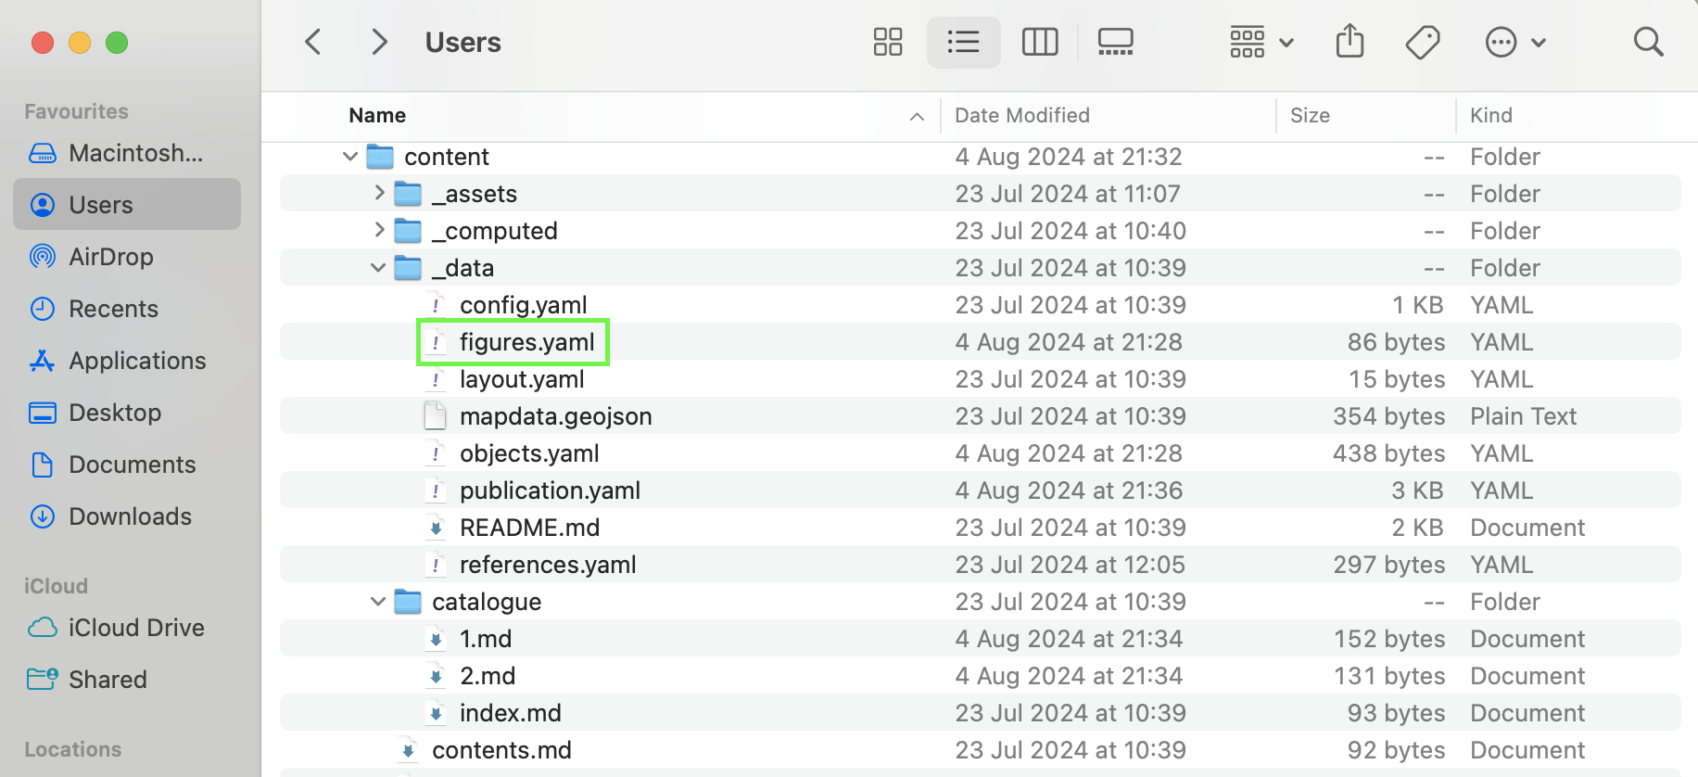

You will find your new figure at the bottom of the figure_list

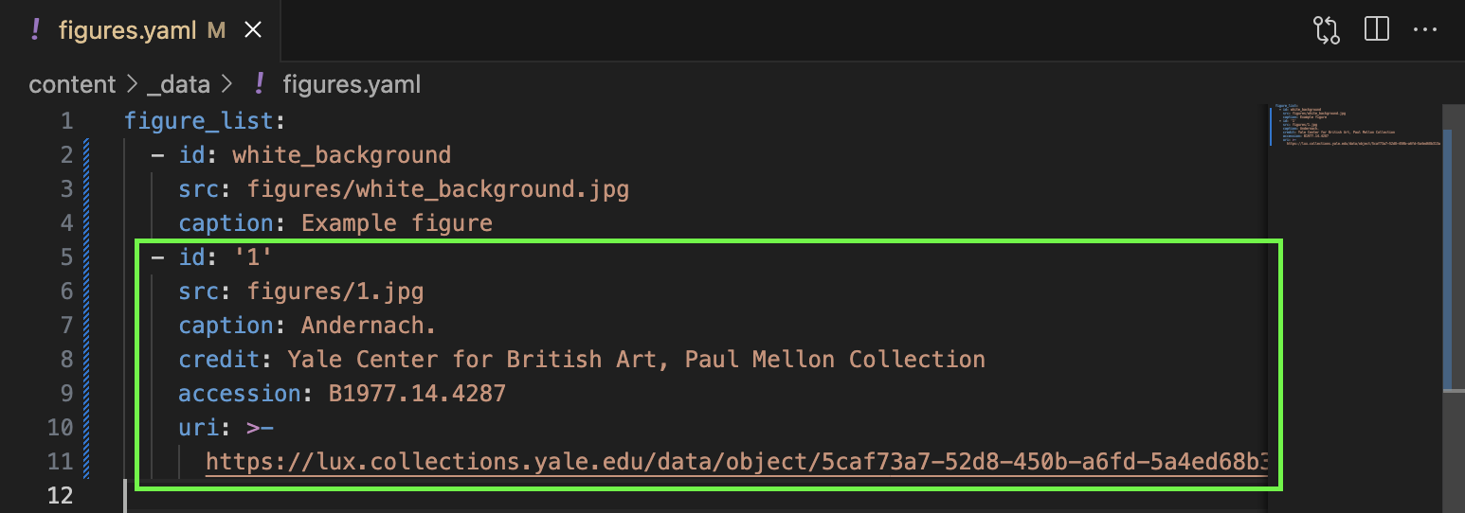

* 1. Change the image used in the intro.md file from ‘white_background.jpg’ to ‘1.jpg’, save the file, and see the change in the Quire preview

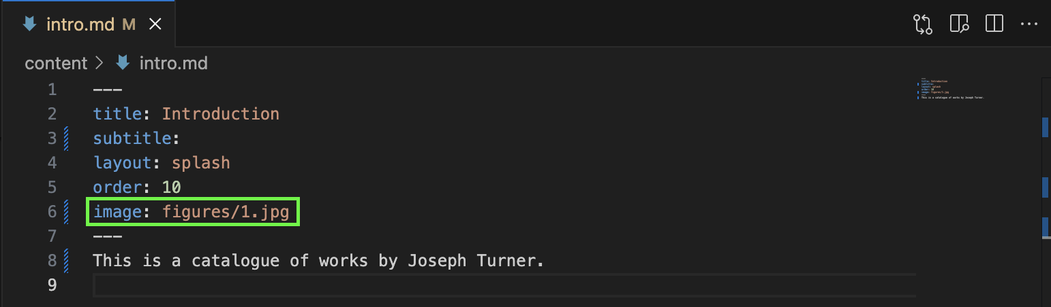

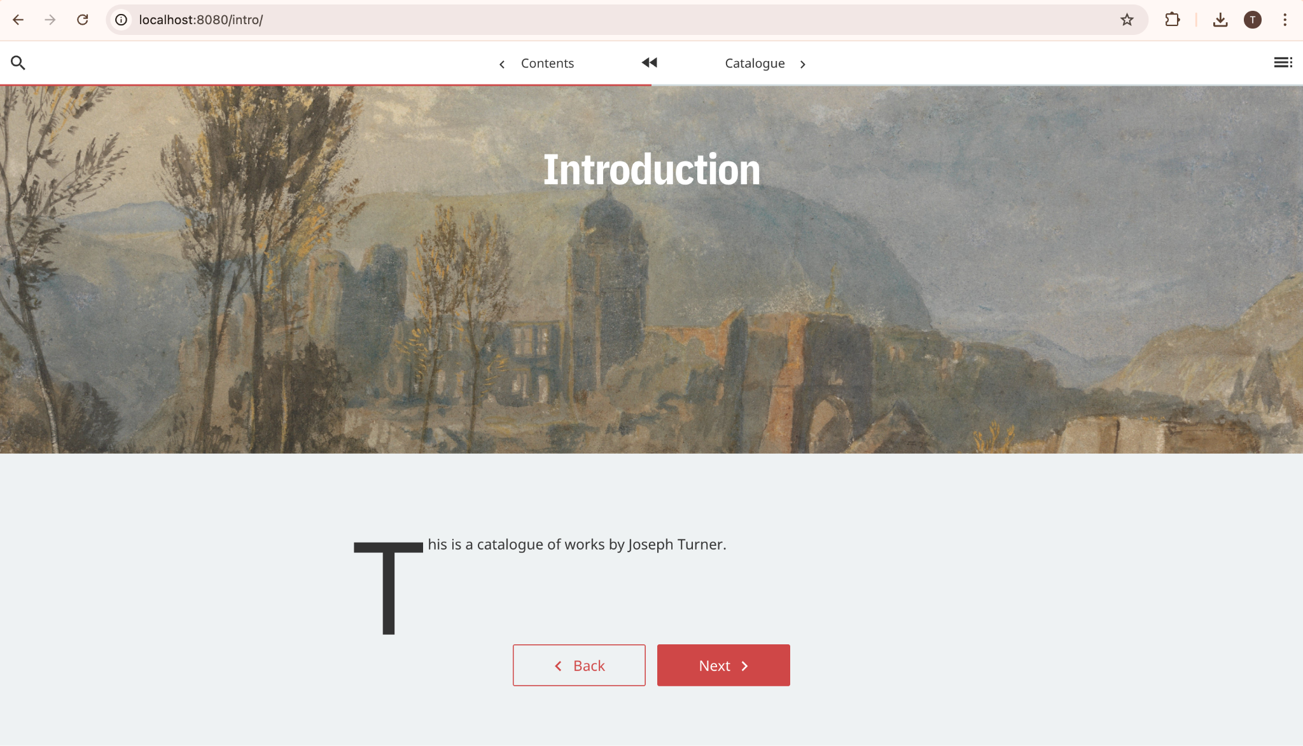

1. Add an object

Figures are images that you can use in your project that come with some information about the image from the Linked Art record. The key difference between figures and objects is that objects also include data about the artwork, such as the name of the artist who created it, the year it was created, the materials used, etc.

Steps:

* 1. Go to the Yale LUX page for your second chosen object and locate the link to its Linked Art record

For our example, we will use the painting ‘Vesuvius in Eruption’ by Joseph Turner found here: <https://lux.collections.yale.edu/view/object/aecc5663-4efc-4322-a49d-b655deaf3fe0>

* 1. Find the object’s Linked Art record (as above)
  2. Use the Linked Art record URI to add the object’s data to objects.yaml. Do this by running the command **‘quire add object <uri>’** in the console

The message in the console lets us know that Linked Art has been added successfully, and provides the object ID and figure ID.

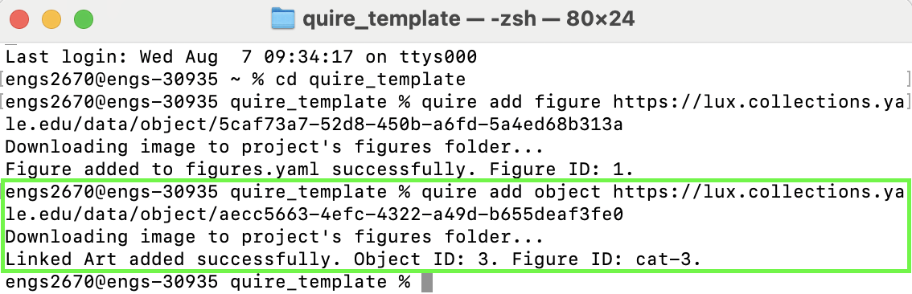

Here is the new object in objects.yaml:

Note: The Linked Art in Quire extension is designed to prioritize the retrieval of names in the Linked Art record that are classified as an English language version of a primary name. In this example, there were two such names in the record: ‘Joseph Mallord William Turner’ and ‘Turner, Joseph Mallord William’. You can edit anything in the yaml files, including the data that has been retrieved by the extension. For example, when more than one name is retrieved, the project author can simply delete the names they do not want to use.

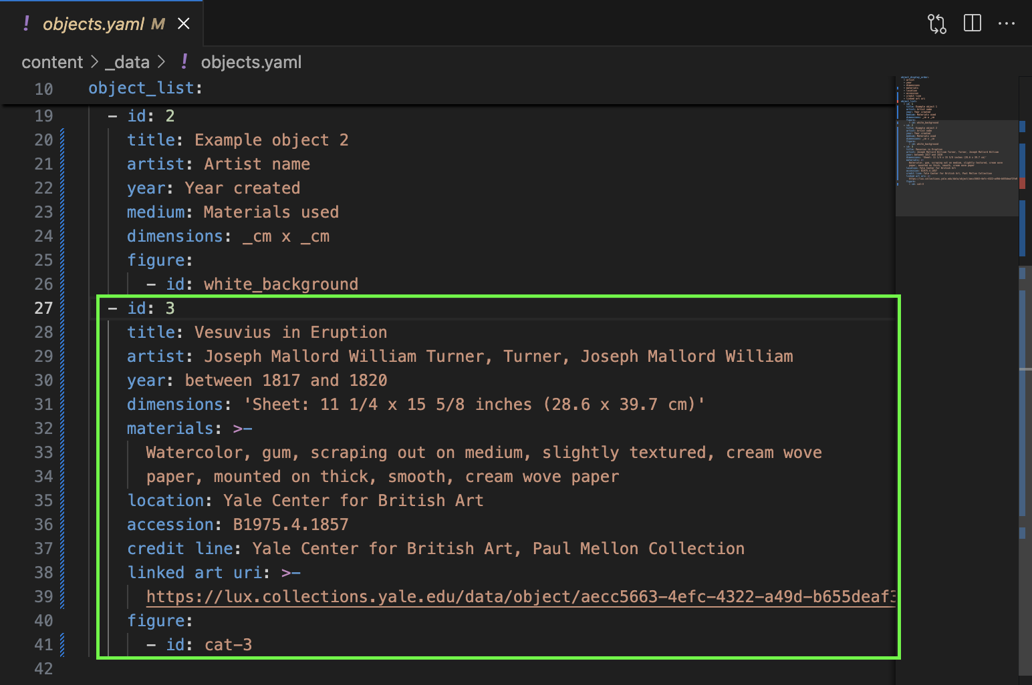

And here is the corresponding figure in figures.yaml:

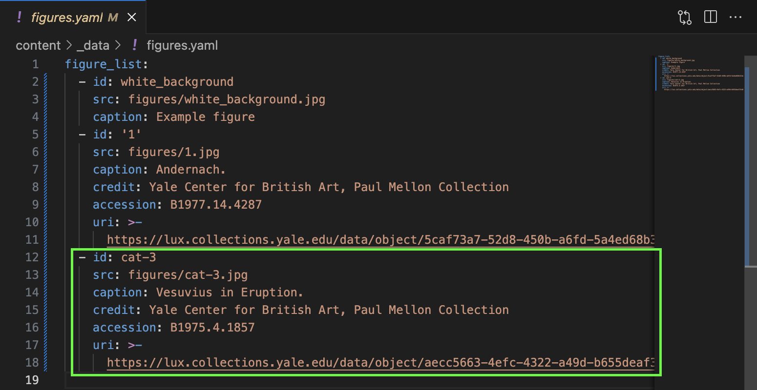

* 1. Change the object used in the 1.md file from ‘white_background’ to ‘3’. You can also write about the object below, the same way you did for the introduction. Save the 1.md file and see the change in the Quire preview

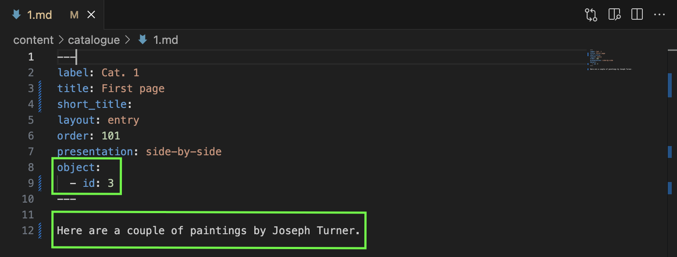

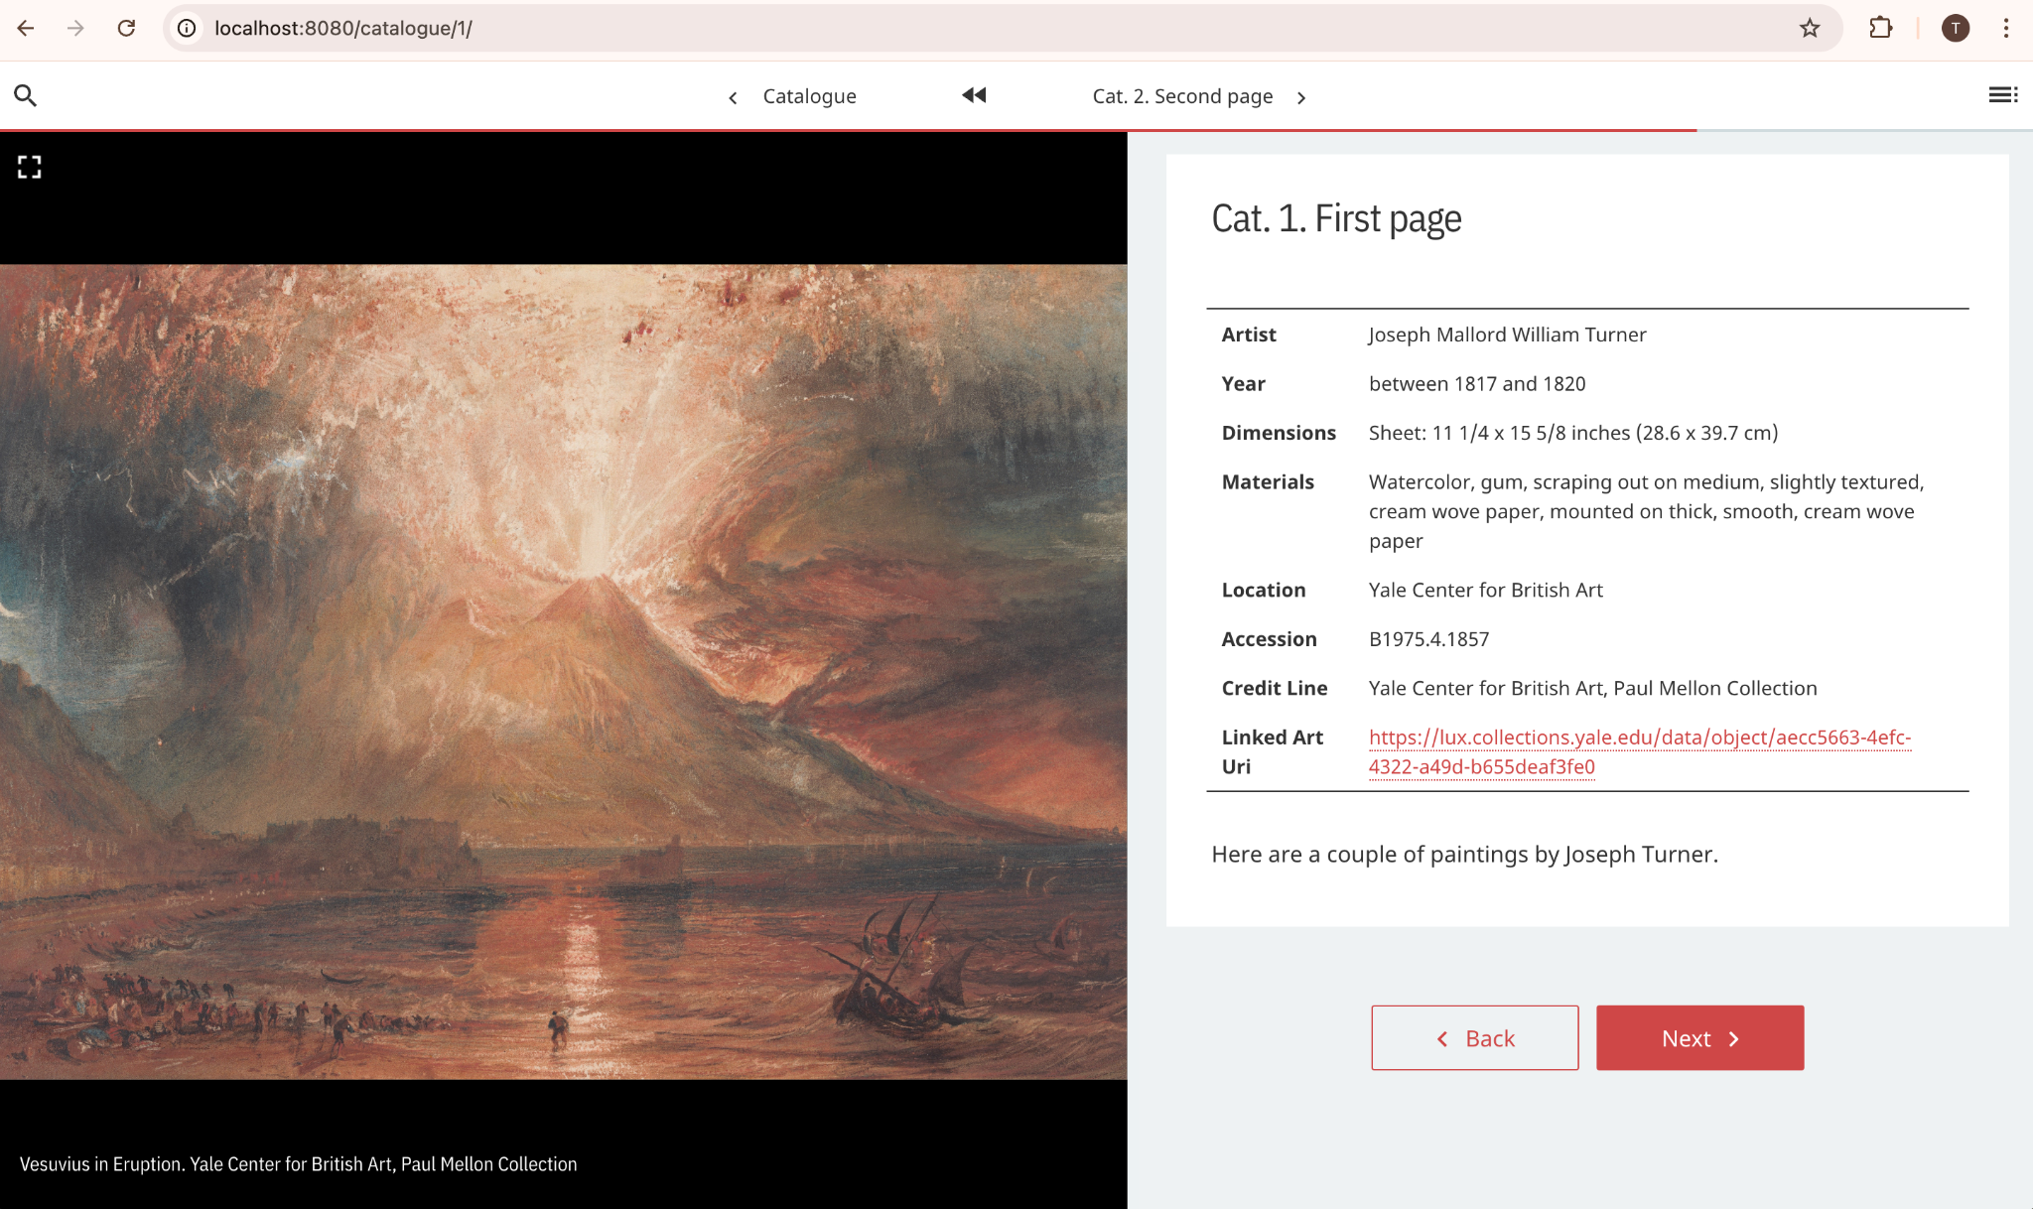

1. Add a figure to an existing object

Quire objects can have more than one figure. This provides a way for users to organize artworks by artist, theme, etc. For our example, we will make our object have two figures of artworks by Joseph Turner

Steps:

* 1. Go to the Yale LUX page for your third chosen object and locate the link to its Linked Art record

In this is example, we will add a figure of the painting ‘Inverary Pier, Loch Fyne: Morning’ by Joseph Turner to the object we created above <https://lux.collections.yale.edu/view/object/e6fa0e33-1575-42f5-b00f-d1494bc0e9d9>

* 1. Copy the URI of the record and use it to add the figure to the object you created above. Do this by running the command **‘quire add object.figure <uri> <object id>’** in the console

Note: there must be a space between the URI and the object ID. In this example, we are adding a figure to the object with the ID ‘3’

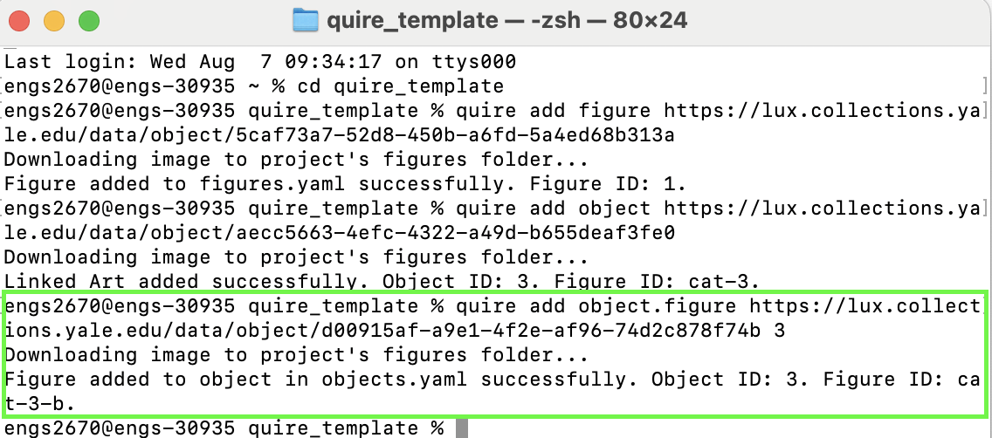

Object ‘3’ in objects.yaml now has two figures: cat-3 and cat-3-b

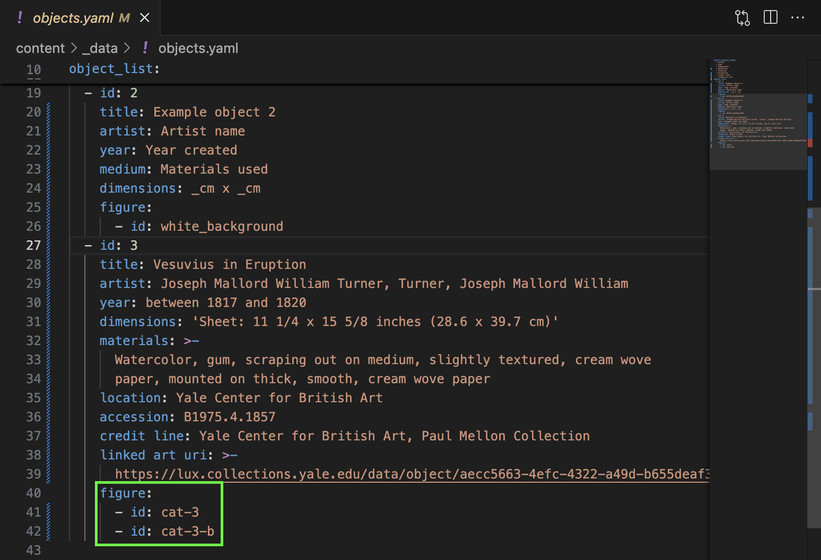

And the figure has also been added to figures.yaml

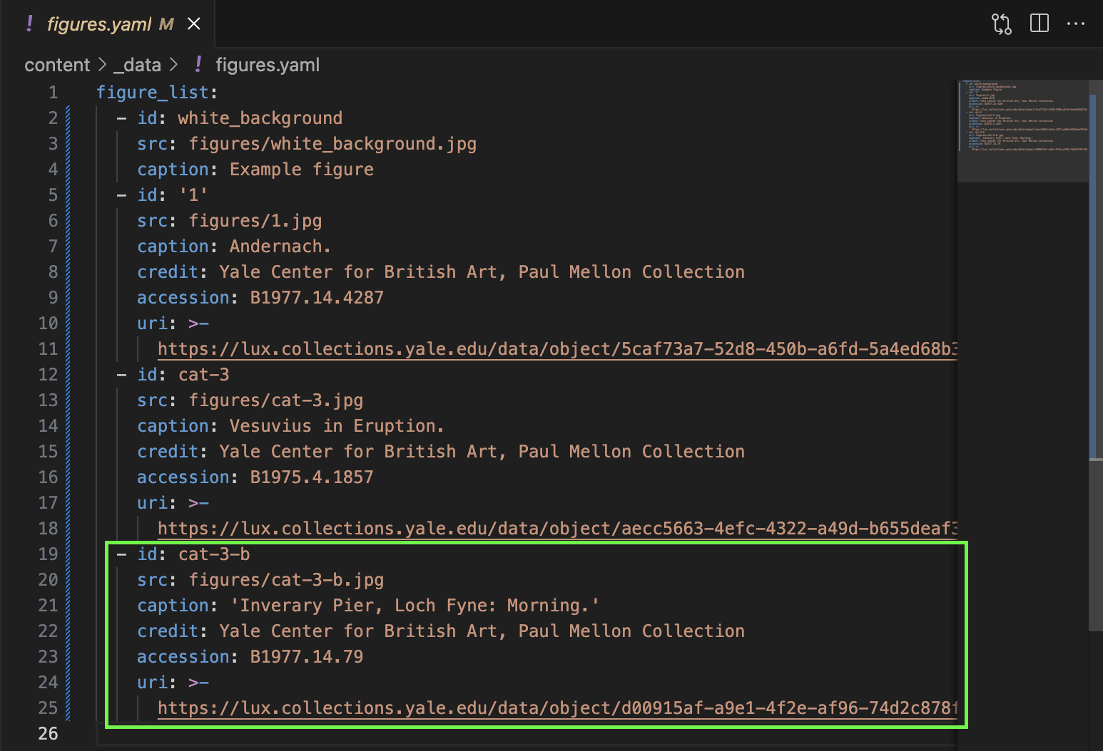

* 1. Rerun the **‘quire preview’** command and see the change

Our object now has two figures we can flip through using the arrows

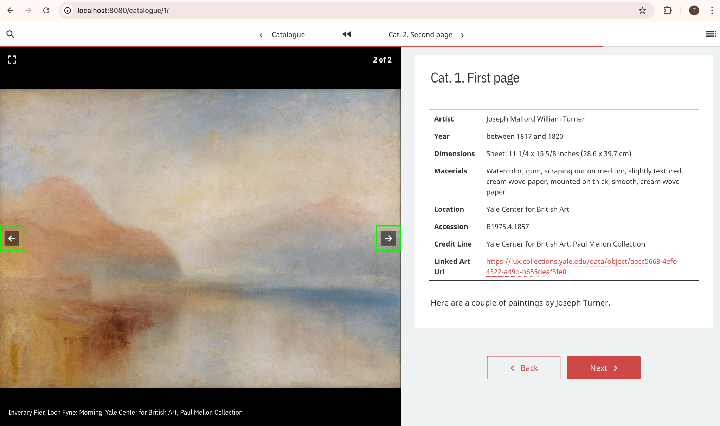

# Bonus activities

1. Retrieve data for more than one object at a time
   * You can process multiple Linked Art URIs at a time by putting them in double quotes and separating them with a space in the command, e.g. ‘ quire add object “<uri1> <uri2> <uri3>” ‘
   * Find some more objects on LUX and give it a try
2. Retrieve data for all the objects featured in an exhibition
   * You can process all the objects that were featured in an exhibition using the Linked Art activity URI for the exhibition
   * The command is the same: ‘quire add object <uri>’
   * When you run the command, an interaction will begin in the console. You will be asked whether you want to create a spreadsheet of the objects, process all the objects, or do both. If you choose to generate a spreadsheet, this will appear in your project folder (‘quire_template’ in our example)
   * Try it with the exhibition ‘Turner and the Sublime’ <https://lux.collections.yale.edu/view/activity/bff2bc73-c45a-4fdf-8c1a-e38cf1dbe773> or find another to try it with
3. Create your own object or figure IDs, or use accession numbers
   * Users may want to give their objects and figures meaningful IDs so that when they see them in the markdown they know immediately what they are.
   * When you add an object or figure using the Linked Art in Quire extension and you do not add an ID to the command, an ID is automatically generated using the lowest available integer or earliest available letter.
   * But the ID can be anything you want. Just type it at the end of your command, e.g. ‘quire add object <uri> my-ID’
   * You can also make the accession number the ID. If you type the word ‘accession’ at the end of the command, the accession number will be automatically retrieved from the Linked Art record and used as the ID, e.g. ‘quire add object <uri> accession’
   * Find some objects on LUX and give it a try
4. Resize an image
   * The Linked Art in Quire extension retrieves the full-size image of the object by default. These are sent to the ‘images’ folder at the directory ‘quire_template/content/assets/images/figures’
   * These images can be large, and sometimes Quire users would like the option to resize them so that they have a smaller file size. Once downloaded, the images cannot be resized using the extension. But they can be resized upon retrieval with the extension using the ‘--resize’ option.
   * Find an object on LUX and try out the resize option by adding ‘--resize’ to your command, e.g. ‘quire add object <uri> --resize’. This will begin an interaction in the console. Follow the instructions to resize the image
5. Add a second image of the same object to a Quire object
   * The Linked Art extension for Quire currently only retrieves the first available image of a given object. Quire users may want to have more than one image of the same object in their Quire object (e.g. different angles, X-ray, etc.)
   * This can be done by saving the image you want to add, placing the image file in the ‘quire_template/content/_assets/images/figures’ folder, adding an entry for the image in figures.yaml, and adding the ID of the figure entry to the ‘figure’ section of the Quire object in objects.yaml

1. Getty recommends using an editor that offers auto-formatting as well as the ability to see and work in multiple text files at a time, such as [Visual Studio Code](https://code.visualstudio.com/), [Brackets](https://brackets.io/), and [Sublime Text.](https://www.sublimetext.com/) **A recommended editor is not required here. Your choice of editor will not have a significant impact on your experience doing these exercises.** We are using Visual Studio Code in our examples.